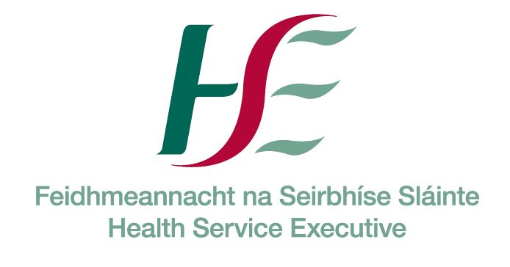



Training Course | Date of Course | Location | Time | Closing date for Applications
safeTALK | Wednesday 20th February 2019 | Kilmore Diocesan Pastoral Centre, Cavan | 9.30 a.m. – 1.00 p.m. | Friday 15th February 2019
safeTALK | Wednesday 20th March 2019 | Child Wellbeing Centre, Castleblayney | 9.30 a.m. – 1.00 p.m. | Wednesday 13th March 2019

Please find enclosed safeTALK Suicide Alertness Training application. If you are interested in attending, please complete and return the application form by the deadline noted, indicating your preference for date and location. Places are limited to twenty five participants on each course; therefore preference has to be given to potential participants who are working within the Cavan and Monaghan areas. For information on all co-ordinating sites please visit www.nosp.ie

It is recommended that anyone who has been bereaved or affected by a suicide within the past 12 months do not attend, as structured training like safeTALK is probably not what they need.
For more information and support for persons bereaved or affected by suicide, contact Pieta House on 01-628 2111.

Due to the high demand for places, a received application is not a guarantee of a place on the workshop. Applications need to be submitted by the deadline outlined above. Participants will be offered a place one week before the workshop date.

Please return completed application forms to:
Ciara Smyth, Connecting for Life Cavan Monaghan
Support Services Building
St Davnet’s Campus
Rooskey
Monaghan
Email: cfl.cavanmonaghan@hse.ie, Tel: 086 1717563.

Yours sincerely

Emer Mulligan
Resource Officer for Suicide Prevention
Cavan Monaghan Mental Health Services

Guidelines for Individual Applicants
SafeTALK

What is safeTALK?
safeTALK is a half day training programme (3.5 hours) that prepares participants over the age of 18 to identify persons with thoughts of suicide and connect them to suicide first aid resources. These specific skills are called suicide alertness and are taught with the expectation that the person learning them will use them to help reduce suicide risk in their community. Following a safeTALK workshop you will be more willing and able to perform an important helping role for persons with thoughts of suicide.

How does safeTALK help prevent suicide?
As a safeTALK trained suicide alert helper, you will be better able to:
- Move beyond common tendencies to miss, dismiss or avoid signs of suicide risk;
- Identify people who have thoughts of suicide;
- Apply the TALK steps (Tell, Ask, Listen & Keep safe) to connect a person with suicidal thoughts to people and agencies that can help.

Who should attend safeTALK?
safeTALK is suitable for everyone (over 18 years) who wants to help prevent suicide and is prepared to become suicide alert: front line workers, community workers, volunteers, Gardai, teachers, clergy, parents, concerned citizens etc. However, safeTALK is not suitable for persons or communities that have recently been bereaved or seriously affected by suicide, nor can it be used to teach the complete set of suicide intervention skills.

What happens at safeTALK training?
Your safeTALK trainer will demonstrate the importance of suicide alertness and help you identify ways people invite help when they’re at risk. Video clips are used which illustrate both non-alert and alert responses. You can expect to leave safeTALK with practical knowledge of how to identify someone at risk and link them to life-saving resources.

Number of places: 25

Time keeping is critical. Participants need to attend the full programme (3.5 hours) to receive certification. Participants arriving late and leaving before the programme is complete disrupt the learning process and will not receive a certificate of completion.

All Workshops are dependent on sufficient numbers to proceed. Short listing for each workshop will commence on the closing date. Participants will be offered a place one week before the workshop date.

All enquiries to: cfl.cavanmonaghan@hse.ie

Applications must be completed in Block Capitals by Applicant, not Organisers/Line Managers.

All fields must be completed otherwise application may not be accepted.

Due to the sensitive content of this program it is strongly advised that those bereaved by suicide do not attend this training for at least 1 year after the bereavement.

Please specify preferred location & date: ___________________________________________________

Name (as it will appear on training certificate):_______________________________________________
Applicants cannot send someone else in their place

Gender: Male ____ Female ____

Are you over the age of 18 years: Yes ____ No ____

Have you been ASIST trained? Yes ____ No ____

Other Suicide Prevention Training to date: __________________________________________________

In completing the section below, please be guided by the main reason you are attending this training, e.g. working capacity, role with a voluntary organisation, as a student etc.

SECTOR (Please tick one only) |  | ORGANISATION / EMPLOYER (e.g. HSE, TUSLA etc.) | HSE Area – Mental Health, Primary Care, Social Care | JOB TITLE / ROLE
Health
Education
Social work
Youth work
Community work
Justice (e.g. Gardai)
Defence (e.g. Army)
Civil service (e.g. Govt dept.)
Local authority (e.g. County Council)
Agriculture
Sports organisation/club
Unemployed
Student

Other (please give details):

Email: _______________________________________________________________________

Contact phone number (Daytime): ________________________________________________________

Please tick to indicate that you understand role play is an essential part of this workshop □

Have you been affected by self-harm, suicide or any other loss in the last year? YES ___ NO ___

Briefly outline why are you interested in this course? : _______________________________________

_____________________________________________________________________________________

_____________________________________________________________________________________

Please return all completed forms to:

Ciara Smyth
Connecting for Life Cavan Monaghan
Support Services Building
St Davnet’s Campus
Rooskey
Monaghan

Email: cfl.cavanmonaghan@hse.ie, Tel: 086 1717563

The Health Service Executive (HSE) as the Data Controller complies with all applicable data protection legislation. Please read our full Privacy Notice at https://www.hse.ie/eng/gdpr

