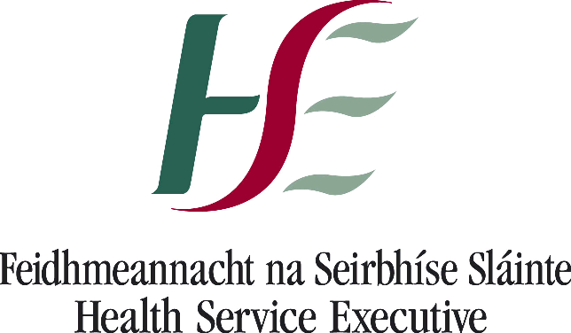



Dates | Location | Time | Closing date for Applications
Wednesday 10th & Thursday 11th April 2019 | Kilmore Diocesan Pastoral Centre, Cavan | 9.00 a.m. – 5.00 p.m. x 2 days  (Tea/Coffee & Lunch provided) | Friday 29th March 2019
Wednesday 15th & Thursday 16th May 2019 | Monaghan Education & Training Centre, Monaghan | 9.00 a.m. – 5.00 p.m. x 2 days  (Tea/Coffee & Lunch provided) | Friday 3rd May 2019

Please find enclosed ASIST (Applied Suicide Intervention Skills Training) application. This training is aimed at professionals and individuals who are working in an area where they are likely to come into contact with someone who is at risk of suicide. If you are interested in attending, please complete and return the application form attached by the deadline noted. Places are limited to twenty four participants on each course; therefore preference has to be given to potential participants who are working within the Cavan and Monaghan areas. For information on all co-ordinating sites please visit www.nosp.ie

The ASIST workshop can be very intense; therefore consideration is given to the relevance of the training to the individual’s current role and to their experience to date of mental health issues. The ASIST programme exists within a suite of suicide prevention training, and it is recommended that potential candidates have experience or some training in mental health issues before attending this course, for example, attend training in mental health promotion or suicide prevention awareness (safeTALK). Preference has to be given to those who are currently working in an area where they are likely to come into contact with someone who is at risk of suicide.

It is recommended that anyone who has been bereaved or affected by a suicide within the past 12 months do not attend, as structured training like ASIST is probably not what they need. For more information and support for persons bereaved or affected by suicide, contact Pieta House on 01-628 2111.

Due to the high demand for places, a received application is not a guarantee of a place on the next available workshop. A waiting list will be maintained and you will be contacted as and when a place becomes available on future workshops scheduled.

Please return completed application forms to:

Ciara Smyth, Connecting for Life Cavan Monaghan

Support Services Building

St Davnet’s Campus

Rooskey

Monaghan

Email: cfl.cavanmonaghan@hse.ie, Tel: 086 1717563

Yours sincerely

Emer Mulligan

Resource Officer for Suicide Prevention
HSE Cavan Monaghan Mental Health Services

Applied Suicide Intervention Skills Training (ASIST)

Aim: ASIST is a two-day intensive, interactive and practice-dominated course designed to help caregivers recognise risk and learn how to intervene to prevent the immediate risk of suicide.

Content: Connecting – sensitize participants to their own attitudes towards suicide.

Understanding – focuses on providing participants with the knowledge and skills to recognise risk and develop safeplans.

Assisting – presents a model of effective suicide intervention.

Networking – generates information about resources in the local community.

For Whom: This workshop is a gatekeeper programme suitable for mental health professionals, social workers, counsellors, ambulance staff, community volunteers, Gardai etc.

It is recommended that participants attend suicide awareness training (e.g. safeTALK) prior to doing this workshop.

Method: Participants develop their skills through observation, supervised simulations experiences and role play in large and small groups.

Number of Places: 24

Time keeping is critical. Participants need to attend the full programme (two full days 9 am to 5 pm) to receive certification. Participants arriving late and leaving before the programme is complete disrupt the learning process and will not receive a certificate of completion.

All Workshops are dependent on sufficient numbers to proceed. Short Listing for each Workshop will commence on the closing date. Participants will be offered a place one week before the workshop date.

Application for consideration of a place on ‘ASIST’ Workshop
For professionals and individuals who are in contact with individuals at risk of suicide
Catchment Area: Cavan & Monaghan

Please Complete in Block Capitals. All questions must be answered.

Due to the sensitive content of this program it is strongly advised that those bereaved by suicide do not attend this training for at least one year after the bereavement.

Please confirm Training Location & Date: ___________________________________________________

Name (as it will appear on training certificate):____________________________________________
Applicants cannot send someone else in their place

Gender: Male ____ Female ____

Are you over the age of 18 years: Yes ____ No ____

Have you trained in safeTALK? If so, when?
___________________________________________________________________________________

In completing the section below, please be guided by the main reason you are attending this training, e.g. working capacity, role with a voluntary organisation, as a student etc.

SECTOR (Please tick one only) |  | ORGANISATION / EMPLOYER (e.g. HSE, TUSLA etc.) | HSE Area – Mental Health, Primary Care, Social Care | JOB TITLE / ROLE
Health
Education
Social work
Youth work
Community work
Justice (e.g. Gardai)
Defence (e.g. Army)
Civil service (e.g. Govt dept.)
Local authority (e.g. County Council)
Agriculture
Sports organisation / club
Unemployed
Student

Other (please give details):

Email: ______________________________________________________

Contact phone number (Daytime): ______________________________________

Briefly, why are you interested in this course? : _____________________________________________________

_____________________________________________________________________________________________

_____________________________________________________________________________________________

Have you been affected by self-harm, suicide or any other loss in the last year? Yes ___ No ___

In what community will you be providing ASIST service? :

_____________________________________________________________________________________________

I have read the Background Information and I am happy that it will meet my training needs. Yes ___ No ___

I understand role play is an essential part of this workshop. Yes ___ No ___

I understand the material covered in this workshop is emotional in nature. Yes ___ No ___

I understand that I must attend this workshop for 2 days, and that I must arrive on time. Yes ___ No ___

Signature: _________________ Date: ___________ Line Manager Signature: ____________________

Please note participants must attend the entire workshop (two full days 9 am to 5 pm) otherwise certificates will not be awarded.

Please return this form to:

Ciara Smyth, Connecting for Life Cavan Monaghan

Support Services Building

St Davnet’s Campus

Rooskey

Monaghan

Email: cfl.cavanmonaghan@hse.ie, Tel: 086 1717563

The Health Service Executive (HSE) as the Data Controller complies with all applicable data protection legislation. Please read our full Privacy Notice at https://www.hse.ie/eng/gdpr

