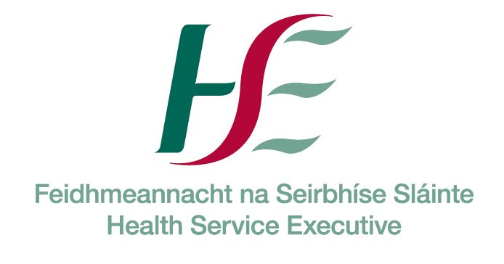

SafeTALK training – Cavan County Board GAA.
Thursday 1st December, 7.00 p.m. – 10.00 p.m.
Crosserlough GAA Clubrooms Kilnaleck.

Guidelines for Individual Applicants

SafeTALK

Aim: safeTALK is a half day training programme (3.5 hours) that prepares participants over the age of 18 to identify persons with thoughts of suicide and connect them to a suicide first aid resource. These specific skills are called suicide alertness and are taught with the expectation that the persons learning them will use them to help reduce suicide risk in their community.

Content: As a safeTALK trained suicide alert helper, you will be better able to:
- Move beyond the common tendencies to miss, dismiss or avoid suicide;
- Identify people who have thoughts of suicide;
- Apply the TALK steps (Tell, Ask, Listen & Keepsafe) to connect a person with suicidal thoughts to people and agencies that can help.

For Whom: safeTALK is appropriate for most members of a community including front line workers, volunteers, parents, teachers, clergy, concerned citizens etc. However, safeTALK is not suitable for persons or communities that have recently been bereaved or seriously affected by a suicide, nor can it be used to teach the complete set of suicide intervention skills.

Method: Video clips which illustrate both non-alert and alert responses. Discuss and practice the steps that contribute to saving lives.

Number of places: 25

Applications must be completed in Block Capitals by Applicant, not Organisers/Line Managers.

All fields must be completed otherwise application may not be accepted.

Due to the sensitive content of this program it is strongly advised that those bereaved by suicide do not attend this training for at least 1 year after the bereavement.

Location & date: ___Thursday 1st December, Kilnaleck__________________________________

Name (as it will appear on training certificate):________________________________________________
Applicants cannot send someone else in their place

Gender: Male ____ Female ____

Are you over the age of 18 years: Yes ____ No ____

Have you been ASIST trained? Yes ____ No ____

Other Suicide Prevention Training to date: ___________________________________________________

In completing the section below, please be guided by the main reason you are attending this training, e.g. working capacity, role with a voluntary organisation, as a student etc.

SECTOR (Please tick one only) |  | ORGANISATION / EMPLOYER (e.g. HSE, TUSLA etc.) | JOB TITLE / ROLE
Health
Education
Social work
Youth work
Community work
Justice (e.g. Gardai)
Defence (e.g. Army)
Civil service (e.g. Govt dept.)
Local authority (e.g. County Council)
Agriculture
Sports organisation/club
Unemployed
Student

Other (please give details):

Work Address :  ____________________________________  ____________________________________ | Home Address :  ___________________________________  ___________________________________

Email: ____________________________________________________________________

Contact phone number(s) (Daytime): ___________________________________________________

Are you available at short notice (i.e. less than 2 weeks)? YES ___ NO ___

Please tick to indicate that you understand role play is an essential part of this workshop □

Have you been affected by self-harm, suicide or any other loss in the last year. YES ___ NO ___

Briefly outline why are you interested in this course? : _________________________________________

_______________________________________________________________________________________

_______________________________________________________________________________________

Please return all completed forms on or before before Friday 25th November to:

Gerry Soden, Cavan County Board GAA Health and Wellbeing Officer.
Email gerrysoden@eircom.net.
Mobile 086-2724180.
Home address Poles, Cavan.

